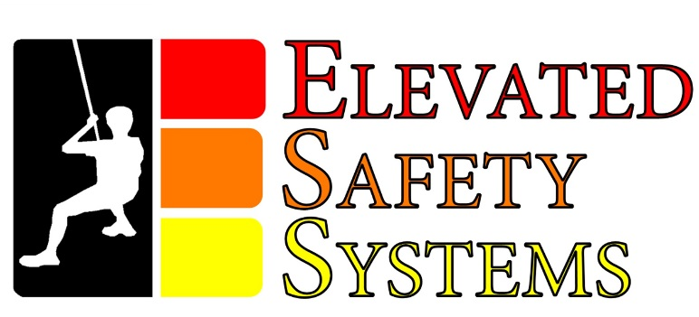

FireEscape EDS™ Harness
Home/Office/Dorm Model
Instruction Manual
11-2023 Edition

Elevated Safety Systems LLC, 4115 Dragon Hwy, Cameron WV, 26033. Elevatedsafetysystems.com. 304-686-3224. MADE IN THE USA.
WARNING! FAILURE TO READ AND FOLLOW ALL OF THE MANUFACTURER’S INSTRUCTIONS AND WARNINGS COULD RESULT IN SERIOUS INJURY OR DEATH.
ALL MANUFACTURER’S INSTRUCTIONS ARE PROVIDED IN THIS BOOKLET. READ THE COMPLETE BOOKLET BEFORE USING THIS PRODUCT. MANUFACTURER’S INSTRUCTIONS ARE ALSO AVAILABLE ON MANUFACTURER’S WEB SITE AT ELEVATEDSAFETYSYSTEMS.COM.

CONTENTS

Page 2 - Guarantee, Warranty, and General Information
Page 6 - Components of the FireEscape EDS™ Harness
Page 8 - Line Configurations For Size and Weight
Page 9 - Determining Where To Place The FireEscape EDS™ Harness
Page 10 - How To Attach The Anchor Line
Page 14 - Practice Putting On The FireEscape EDS™ Harness
Page 18 - Packing The FireEscape EDS™ Harness
Page 19 - What To Expect In An Actual Emergency

GUARANTEE, WARRANTY AND GENERAL INFORMATION

100% GUARANTEE FREE REPLACEMENT if the FireEscape EDS™ Harness is lost or damaged during an officially documented emergency evacuation.

Elevated Safety Systems, ESS, expressly warrants that all ESS products are free from defect in material and workmanship from date of purchase and shipment. This warranty is for original purchaser only. Excluding loss or damage during a documented emergency, this warranty only covers defects in material and workmanship, and it does not cover results from normal wear and tear, neglect, abuse or accident. ESS’S OBLIGATION UNDER THIS WARRANTY APPLIES FOR THE LIFE OF THE PRODUCT AND IS LIMITED TO REPLACEMENT OF PRODUCT ONLY. COMPLETE WARRANTY INFORMATION VIEW AT ELEVATEDSAFETYSYSTEMS.COM.
Keep this user instructions/information after separated from harness, descent control device and escape anchor, and retain in a permanent record; Copy the user instructions/information and keep a copy with the harness, descent control device and escape anchor. Refer to the user instructions/information before and after each use.
The Patent Pending FireEscape EDS™ Harness (FEH) is intended to be used at elevated positions where an emergency evacuation is necessary to protect lives.

The FireEscape EDS™ (Emergency Descent System) Harness is a revolutionary design that is light weight, and quickly used in an emergency evacuation from an elevated danger.

The FireEscape EDS™ Harness can be used on an unconscious or injured person if necessary. If there is no other alternative and lives are at risk, the FEH can be placed on an unconscious or injured person and once anchored to a secure location, the unconscious or injured person can be lowered from danger with no braking action. You are not going to fall. The slowed rate of descent is built into the FEH. The unconscious or injured person can be assisted once they are within reach of other people on the ground.

The Easy-Grasp Brake Handle is quickly found and used even in the dark. The Kevlar Brake is extremely sensitive and can slow or stop the descent. And if necessary, can easily hold a suspended person in one location with very little effort. While holding the Brake Handle keep your hand or hands next to your body and slide the Brake Handle up to descend or push the Brake Handle towards your feet to slow or stop. DO NOT HOLD THE LINE WHILE DESCENDING, IT WILL BURN YOUR HAND. KEEP YOU HANDS ON THE BRAKE HANDLE. YOU WILL NOT TOPPLE BACKWARDS.

The FireEscape EDS™ Harness utilizes the ESS patented 1EDS Rack, and Samson Tech 12 Technora 1/4" Line. This line is super strong and will not melt. The Samson Line has a minimum breaking strength of 7,300 pounds and has a decomposition point of over 900 degrees! This Technora Line is very similar to Kevlar, it is very tough and hard to cut.

The FireEscape EDS™ Line Bag is Florescent Yellow, 250D, water repellant fabric, NFPA-701-2015. The Samson Tech 12 Technora 1/4" Line is machine wrapped and packed at ESS. This machine wrapping allows for the smallest amount of space needed while helping to prevent kinks and knots. The FireEscape EDS™ LINE BAG CANNOT BE REPACKED IN THE FIELD. If the line is removed from the FireEscape EDS™ Line Bag, a new Line Bag must be purchased, or if used in an officially documented emergency, a new Line Bag and/or Harness will be provided free of charge. 50 and 100 Feet Line Bags are permanently attached to the FireEscape EDS™ Harness. Line Bags over 100 feet are not attached to the FireEscape EDS™ Harness and will need to be dropped to the ground prior to an emergency descent.

Components – Industrial grade polyester webbing, 5,000 MBS. 1EDS Rack Descent Control Devise, 6061 T6 Aluminum. Samson Tech 12 Technora 1/4" line, MBS 7,300 lbs., decomposing point of 934 Degrees. Yoke Hardware. Tex 210 and Tex 120 Para-Aramid Kevlar Thread. FEH Line Bag is 250D, water repellant, NFPA-701-2015 fabric.

Maintain harness, line and descent control device where metal components are not subjected to corrosion or deterioration. Store in dry location away from presence of moisture. Repair to harness, line or descent control device shall only be performed by manufacturer.

Warning - Do not interchange non-Elevated Safety Systems components with the FEH, 1EDS Rack, Line, or Line Bag. The use of none ESS approved components void the guarantee and warranty and may result in serious injury or death.

Warning - 1EDS Rack shall not be used for any other purpose than what it is intended for. Misuse of the 1EDS Rack outside of its expressed purpose, limitations, or for any other purpose may result in serious injury or death.

Warning - Damage to equipment and/or injury to a user may result from an uncontrolled, long, or heavy load descent. User must read and follow the FireEscape™ EDS Harness Instruction Manual, and use the correct Size, Weight, and Line Configuration Level. Failure to do so, may result in serious injury or death.

Warning – In an emergency situation where an emergency evacuation is necessary, EVERY SECOND COUNTS. Practice putting on the FireEscape EDS™ in the dark until you are an expert at it. Make sure the Line Configuration used is correct for your weight. You must be able to descend as quickly and as safely as possible. Your life depends on it.

The following are alarming statistics on home fires. According to Deputy U.S. Fire Administrator, Glenn Gaines, home fires kill more Americans each year than all natural disasters in the United States combined. There are approximately 400,000 home fires in the U.S. each year (NFPA).
More than 3,000 Americans die in home fires each year, including approximately 500 children. One fire-related death occurs every 2 1/2 hours. Avg 8 fire deaths per day. Fire-related injuries occur every 35 minutes (FEMA).
According to Consumer Safety Director John Drengenberg of Underwriters Laboratory (UL), “Thirty years ago you had on average 14 to 17 minutes to escape a house fire. Today, with the prevalence of synthetic materials in the home, you have roughly 2 to 3 minutes to get out.”
UL has determined that a modern home can be completely engulfed in flames in less than 4 minutes. In 30 seconds to 1 minute the hot, smoky air can instantly burn your lungs. Plus, fires generate highly poisonous gases, including carbon monoxide and hydrogen cyanide. Just 2 or 3 breaths can cause you to pass out. Survival time is cut down to less than 1 minute if you are breathing the smoke, fumes and gases!
In 3 minutes, flames will spread to the second floor. Rescuing anyone still trapped there may be impossible.
In 2021, West Virginia had 40 home fire fatalities. In 2018, Pennsylvania had 152 home fire fatalities.

COMPONENTS OF THE FIREESCAPE EDS™

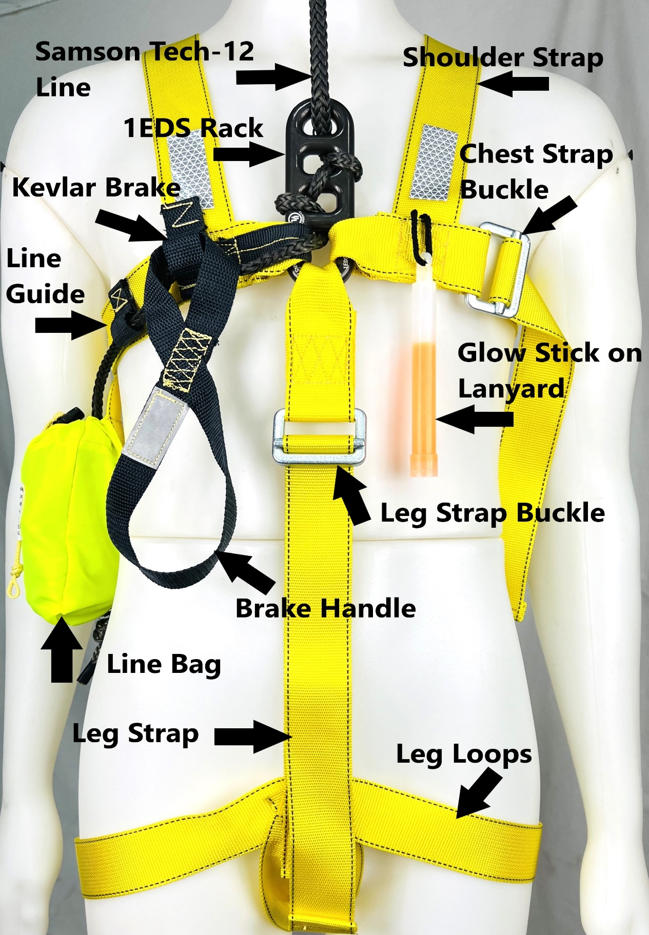
FEH Front

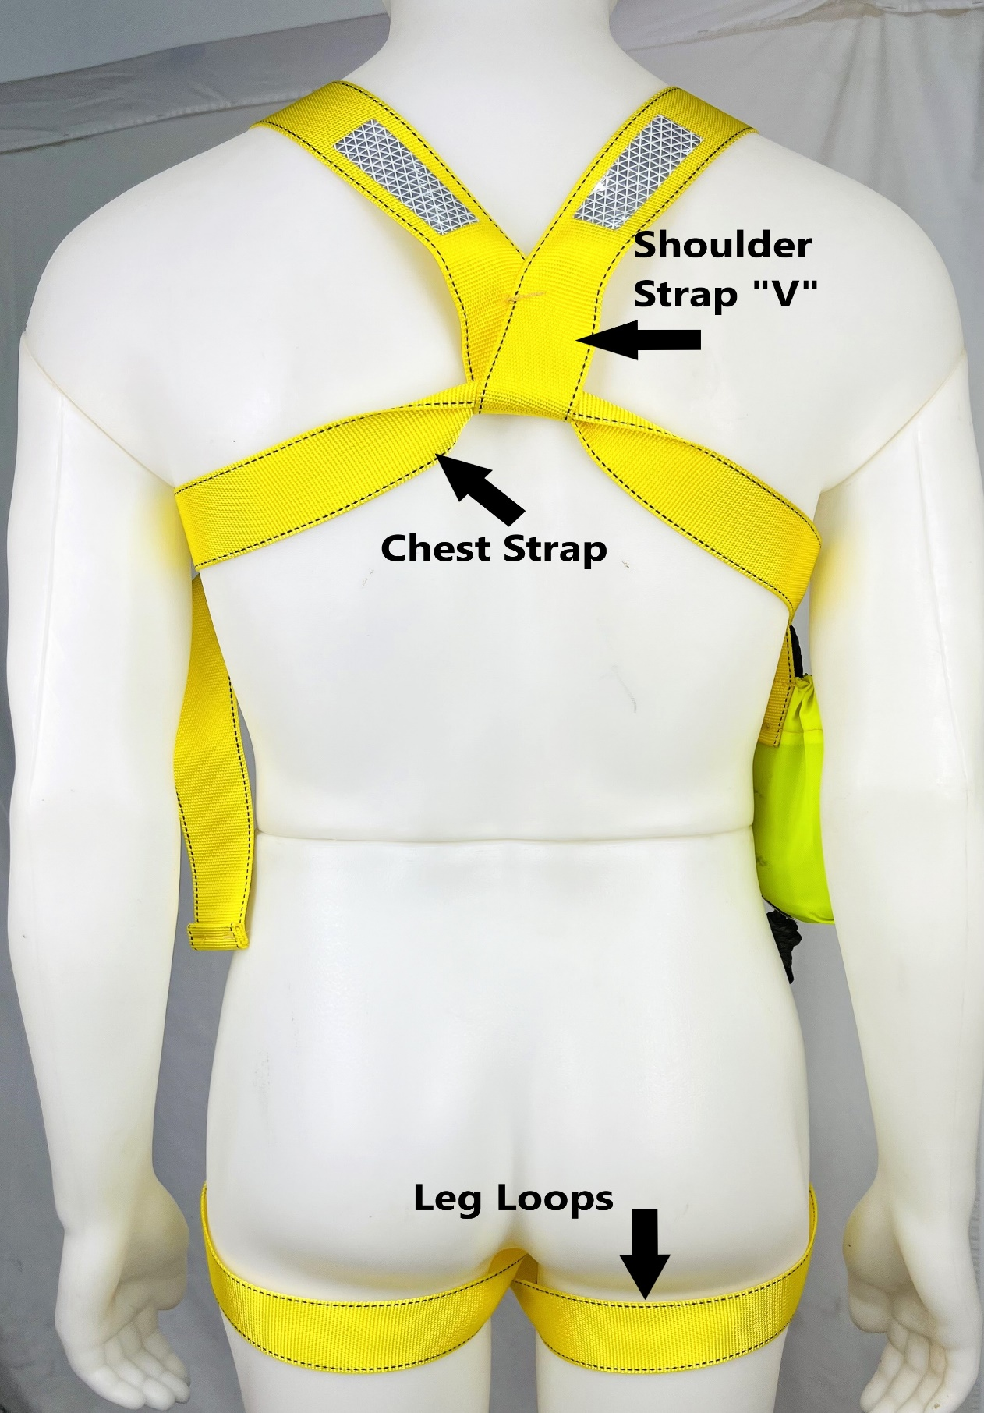
FEH Rear
LINE CONFIGURATIONS FOR SIZE AND WEIGHT

1 Small/ Medium (S/M) Line Configuration - Recommended Weights 70 to 180 lbs. Photo 1

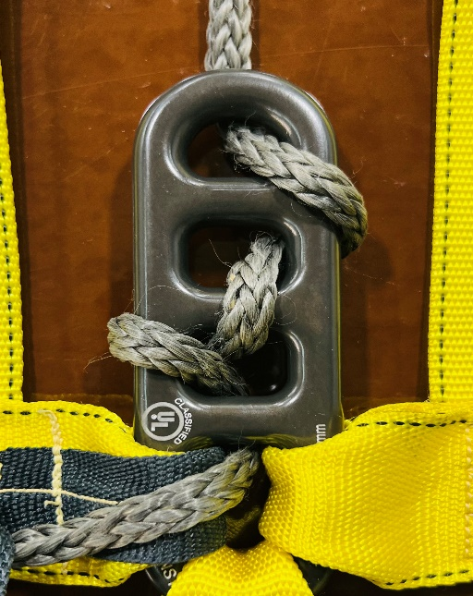
S/M Line Configuration, Photo 1

2 Large/ Extra Large (L/XL) Line Configuration. Recommended Weights 180 to 280 lbs. Photo 2

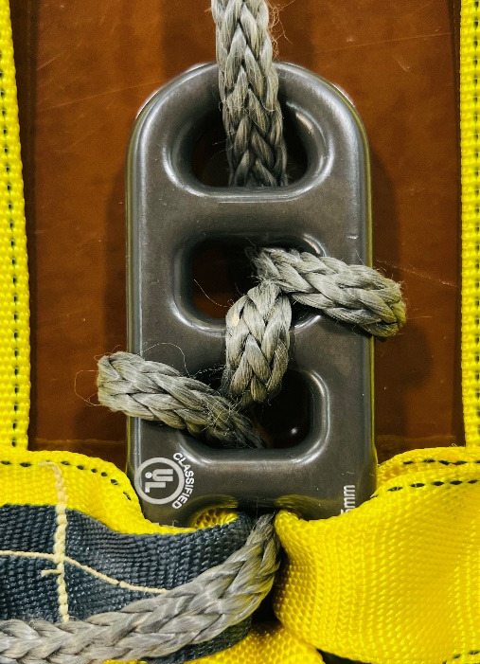
L/XL Line Configuration, Photo 2
3 Extra Extra Large (XXL) Line Wrap Configuration. Recommended Weights 280 to 310 lbs. Photo 3

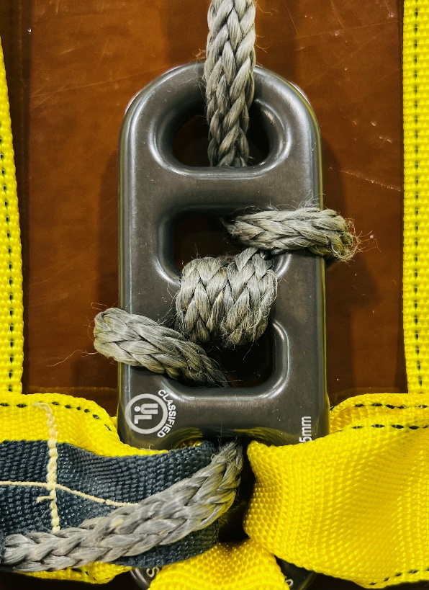
XXL Line Configuration, Photo 3

DETERMINING WHERE TO PLACE THE FIREESCAPE EDS™ HARNESS

- In a home or living quarters, you want to keep the FireEscape EDS™
Harness where it is nearest your best escape location. For most people that is the bedroom window closest to your bed. That location also gives you an excellent anchor, your bed. And an excellent place to keep your FireEscape EDS™ Harness, under the bed. Note – A suitable anchor is anything that is heavy enough to support your weight and/or will not fit through your escape window or opening. Also, you must be able to attach the Anchor Line to your anchor in a manner where it will not come off!

2 If the FireEscape EDS™ Harness is intended to be used in an office, keep it near where you are going to anchor it. A large desk or a closed solid interior door that you can place the Anchor Line around. Something large enough or heavy enough that your weight will not pull it through your escape window or opening. If using a door, place the Anchor Line completely around the door half way up, and then make sure the door is closed.

3 You must have the ability to open your escape window or opening. In the home, make sure the designated escape window will open easily. If in an office building, you may need a large emergency hammer to break the heavy tempered glass windows. Strike the window in a lower corner. Whatever it takes, have it handy.

HOW TO ATTACH THE ANCHOR LINE

- A bed is a perfect location to anchor. Remove the mattress and box spring. Loop the 10 feet Anchor Line around the middle of the metal frame on the far side of the bed and place the end through the loop. Box spring and mattress not shown. Photo 1

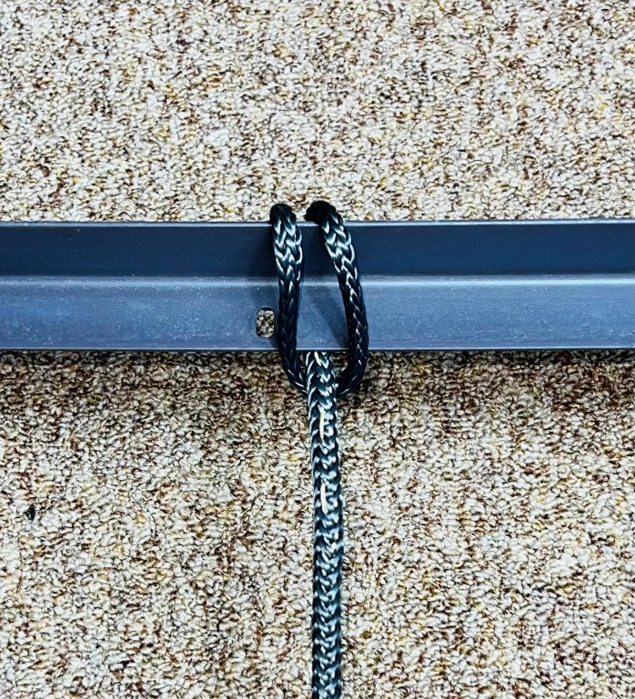
Photo 1
- Next, wrap the Anchor Line around the middle metal brace if available and tie another half-hitch knot underneath. Photo 2

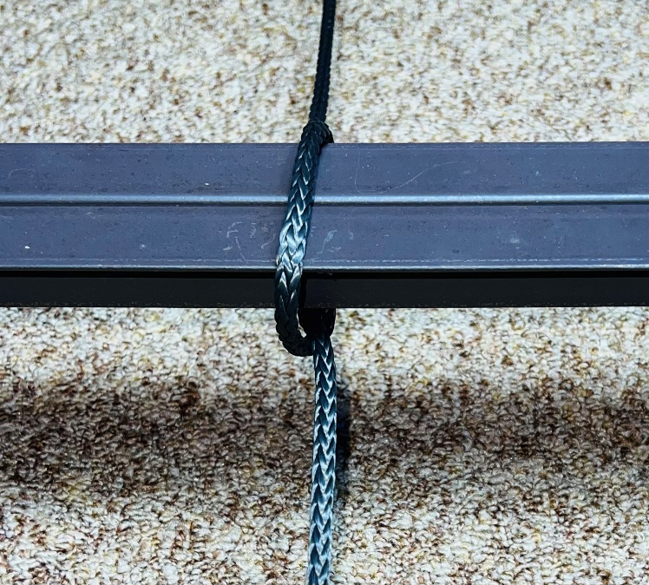
Photo 2

3 Wrap the Anchor Line around the nearest metal frame in the middle and
tie another half-hitch knot. Photo 3A, 3B

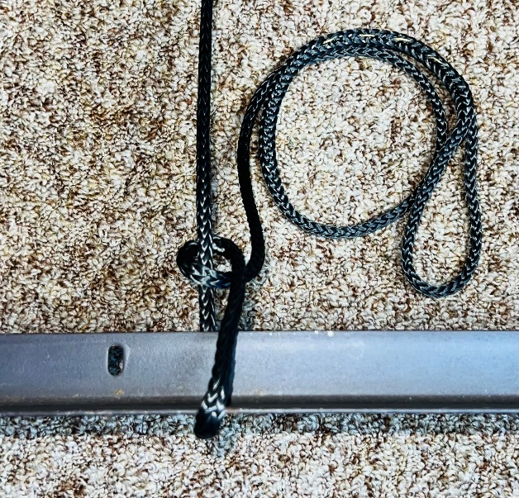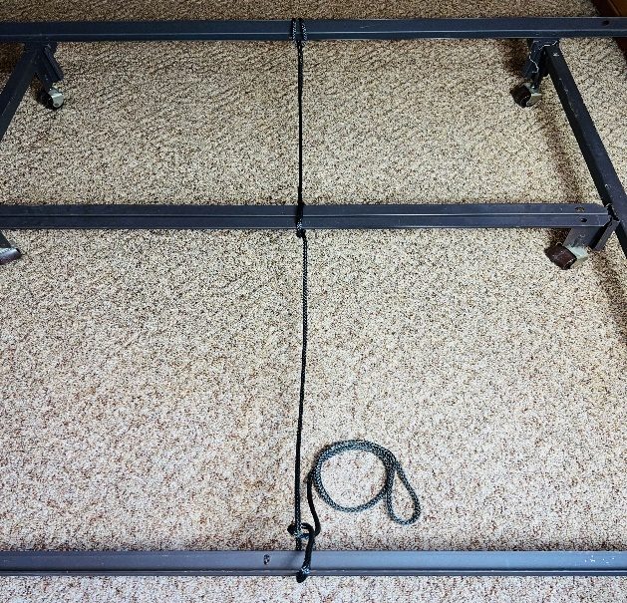
Photo 3A Photo 3B

4 Attach the Carabineer to the end Anchor Line Loop and the FireEscape EDS™ Harness Line Loop. Be sure to lock the gate on the carabineer. Photo 4

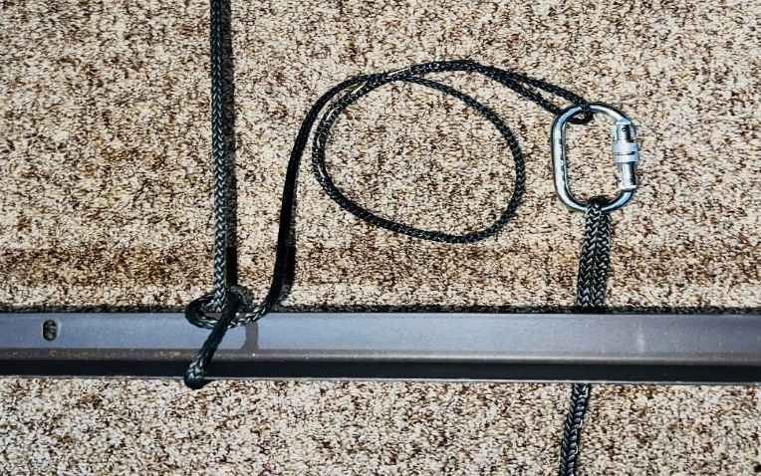
Photo 4

5 After the FireEscape EDS™ Harness Line Loop is attached to the Carabineer and Anchor Line make sure the FireEscape EDS™ Harness line length is where you can reach your escape window or opening while wearing the FireEscape EDS™ Harness as shown in Photo 5. This is where you want the line to be tight as you are starting out your escape window or opening. Adjust the line accordingly. This will prevent you from slipping down more than a few inches. Remember – You are not going to fall if the FireEscape EDS™ Harness is properly put on and anchored.

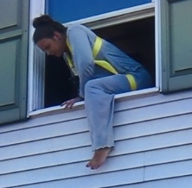
Photo 5, This is where the line needs to be tight.
6 If the Line is longer than needed to reach your escape window or opening, remove the carabineer from the Anchor Line and loosely wrap the Anchor Line around the metal bed frame until the excess line is shortened. Leave enough line to tie another half hitch knot as shown. The weight of the box spring and mattress will compress the line against the frame. Photos 6

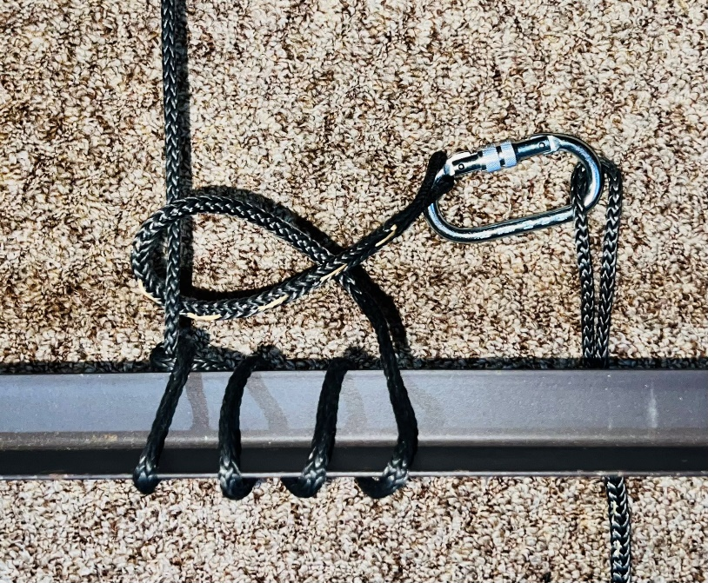
Photo 6

PRACTICING PUTTING ON THE FIREESCAPE EDS™ HARNESS

1 After you have the Anchor Line secured and the correct line length to reach your escape window or opening, you want to practice putting on
the FireEscape EDS™ Harness a few times. Before each practice, extend the Chest Strap and the Leg Strap until 6” of free end remains at the buckles. You want as much room as you can get when putting it on.
Photo 1

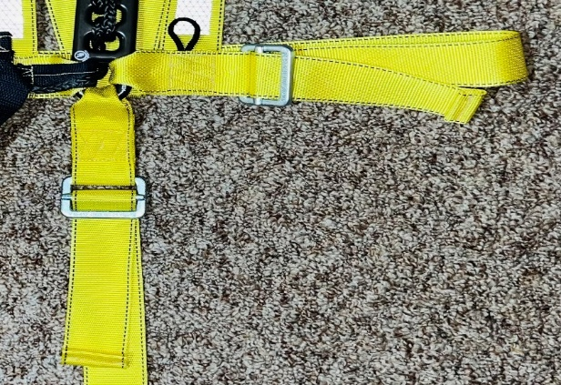
Photo 1
2 Lay the FireEscape EDS™ Harness with the rear area of the Chest Strap and the Shoulder Strap “V” on top in the storage container. Lay the Glow Stick still in its wrapper on top of the “V”. If it is at night and the electric is off, you want to be able to find the Glow Stick first. Replace the lid on the container and slid it under your bed. Photos 2A, 2B

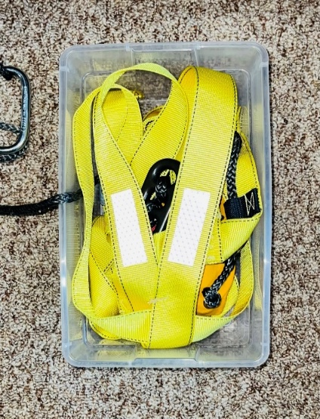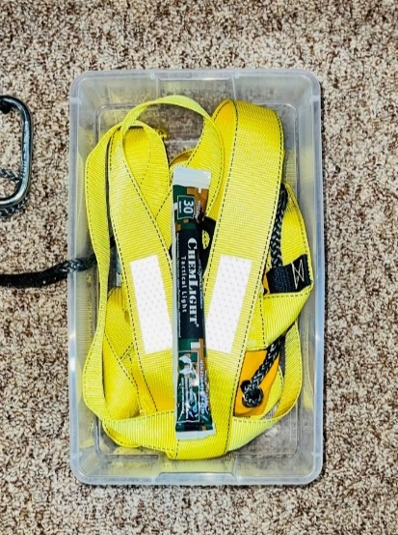
Photo 2A Photo 2B

3 To practice, remember you may be doing this in the dark. So after you have practiced a few times, do it with your eyes closed or in the dark.

4 Find the FireEscape EDS™ Harness storage container and pull it out from under the bed. Open the container and find the Glow Stick wrapper. Lay it to the side. If this was an actual emergency in the dark, you would tear open the Glow Stick wrapper, remove the Glow Stick and strongly bend it in half to break the internal capsule to make it glow, then lay it to the side.
Photos 4A, 4B, 4C, 4D

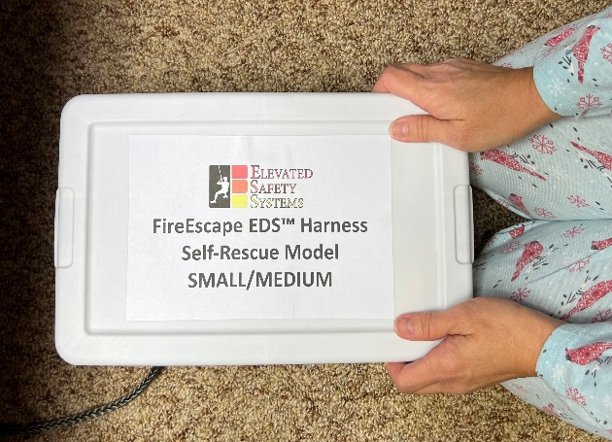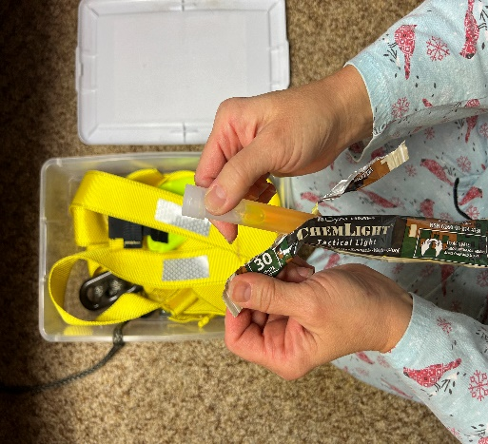
Photo 4A Photo 4B

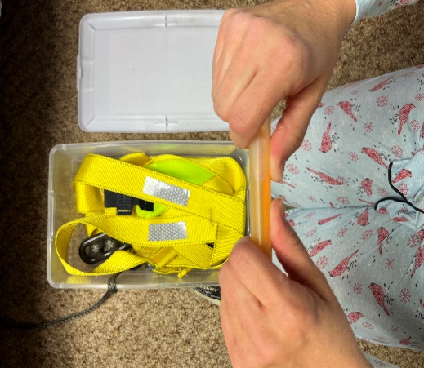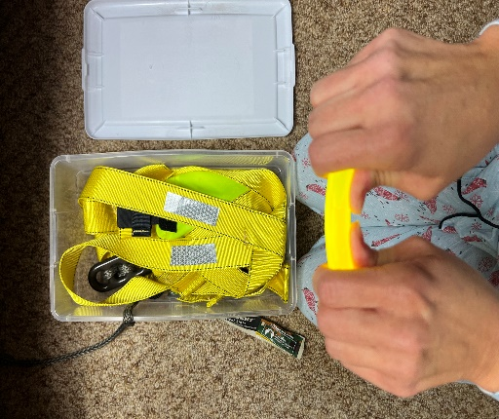
Photo 4C Photo 4D

5 Find the Shoulder Strap “V” and Chest Strap. You can do this by feel with your eyes closed. Grasp the Chest Strap on each side of the “V” with both hands. Lift the FireEscape EDS™ Harness out of the container and place your head up between the Shoulder Straps while pulling the Chest Strap down the back of your neck and shoulders. Photos 5A, 5B, 5C, 5D

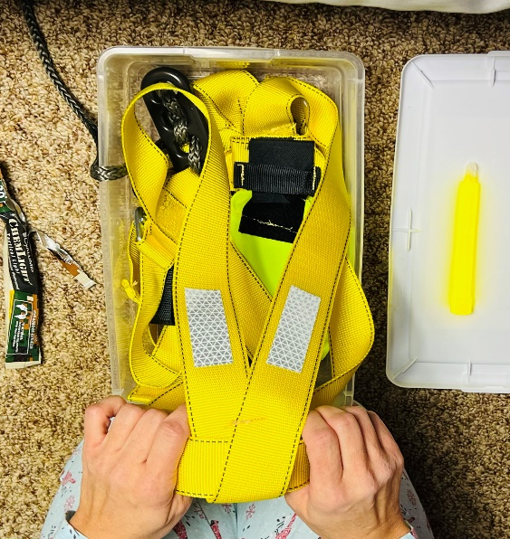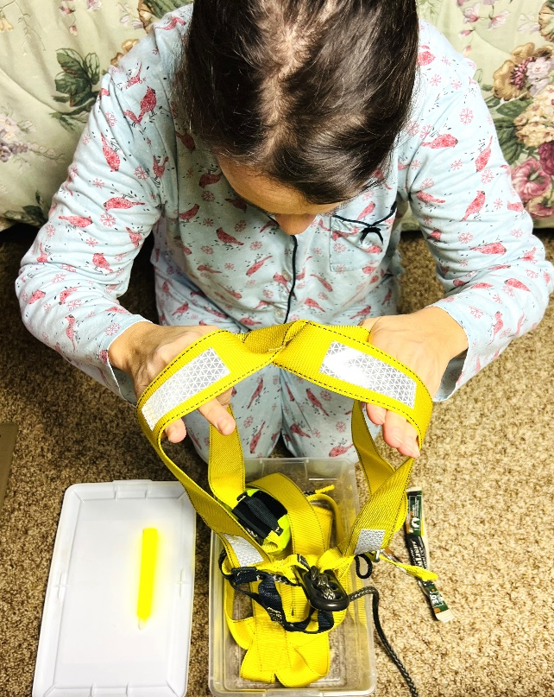
Photo 5A Photo 5B

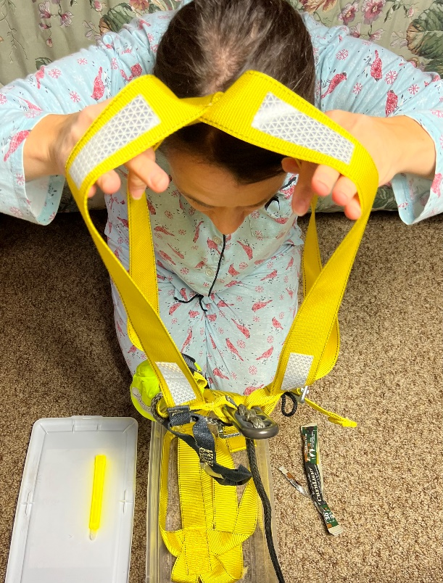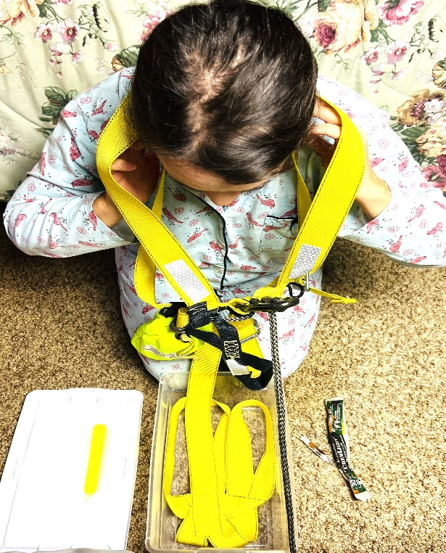
Photo 5C Photo 5D
6 Place both arms up through the Chest Strap on each side. Tighten the Chest Strap by first pulling the slack out of the Chest Strap while holding up the Line Bag with your right hand. This will pull the excess Chest Strap through the Shoulder Strap “V” in the rear. Then pull on the free end of the Chest Strap as many times as necessary and tighten it with the buckle. Make sure the Chest Strap is snug and the 1EDS Rack is over your sternum.

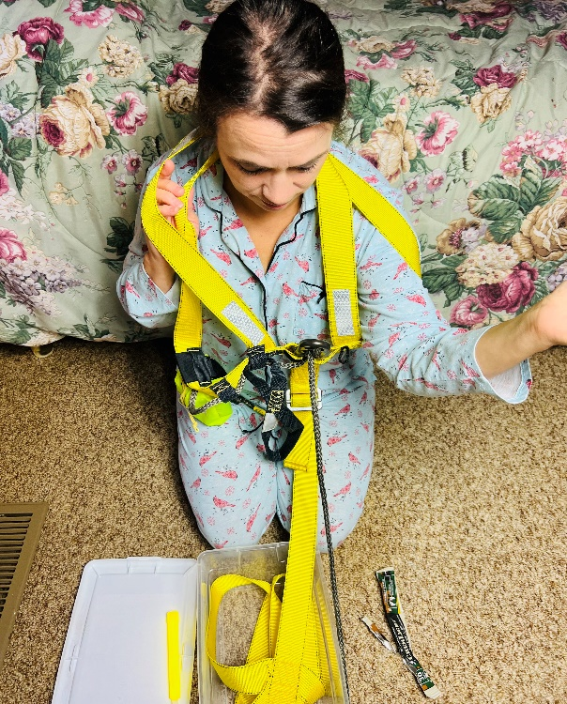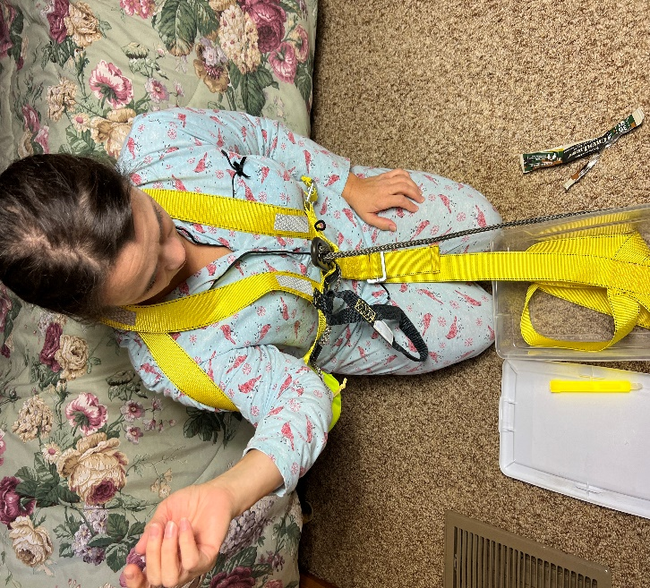
Photo 6A Photo 6B
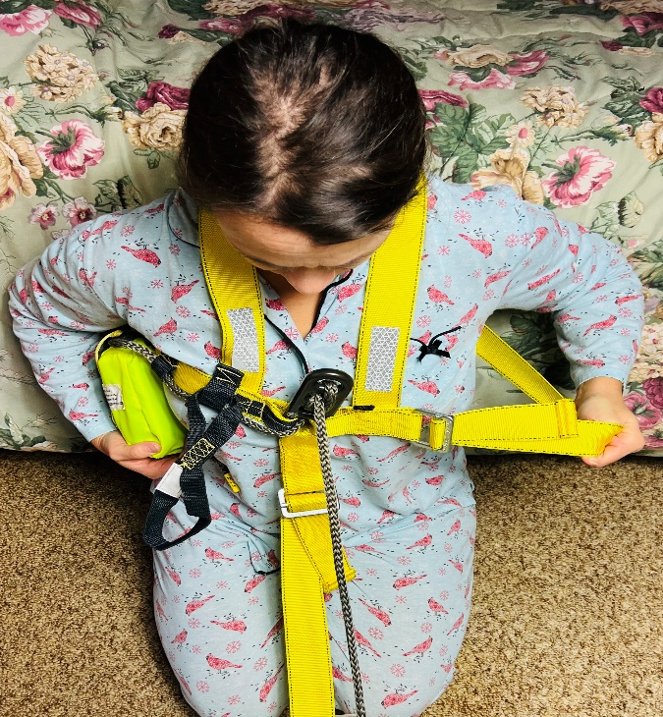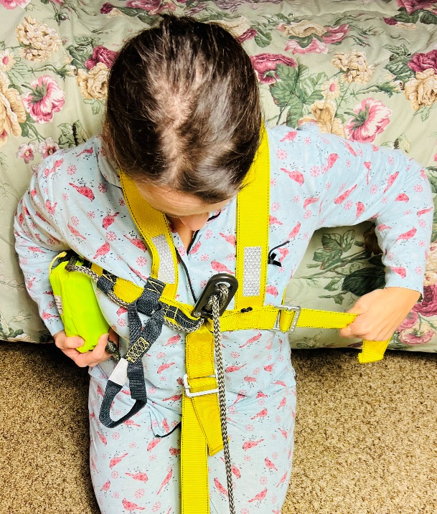
Photo 6C Photo 6D
7 Place one leg in both Leg Loops and pull down on the Leg Strap to tighten the leg loops in your crotch. Photos 7A, 7B, 7C

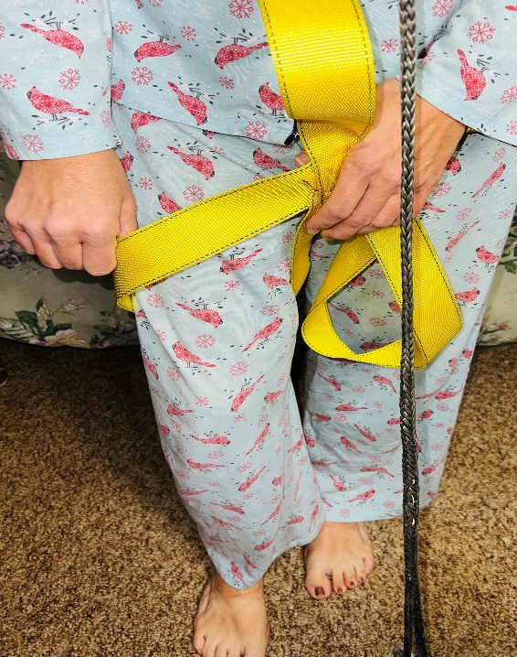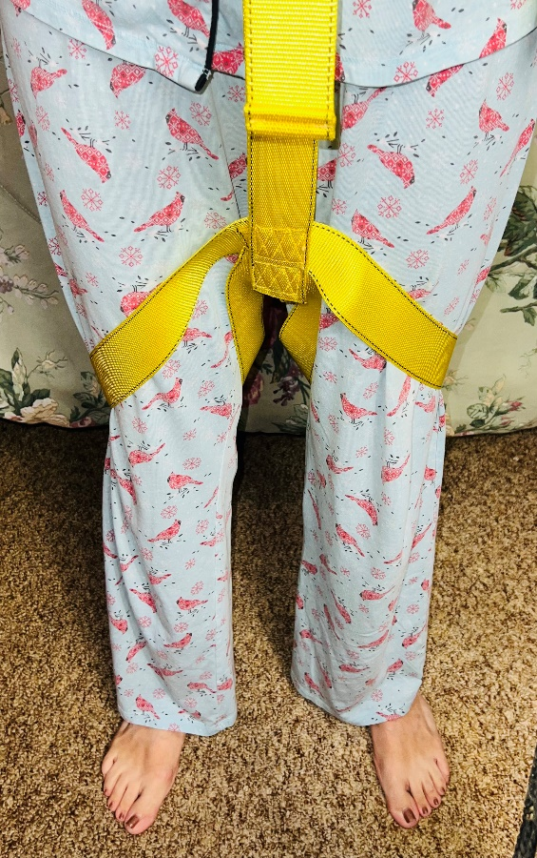
Photo 7A Photo 7B

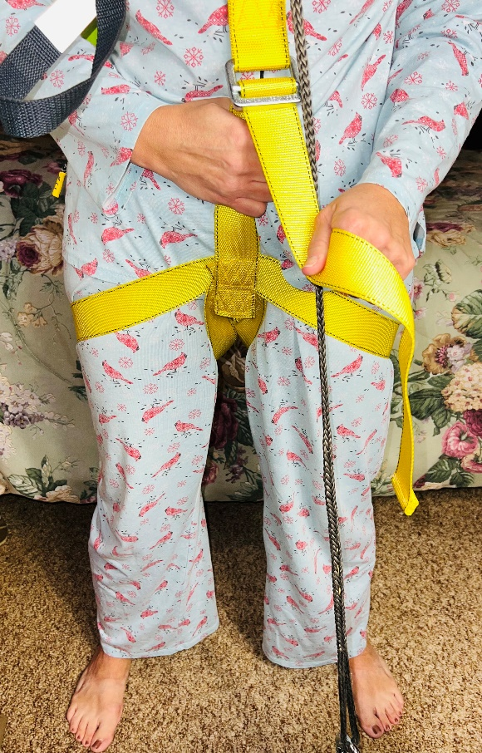
Photo 7C
8 The FireEscape EDS™ is properly put on. Attach the Glow Stick built in hook to the Lanyard Loop on the left side of the Chest Stap. It will help you see as you exit through your escape window or opening, and it will help Emergency Personnel find you. The Glow Stick will burn bright for 5 minutes. Photos 8A, 8B, 8C

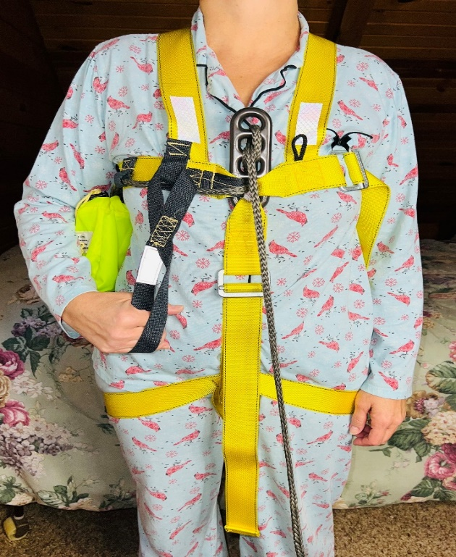
Photo 8A

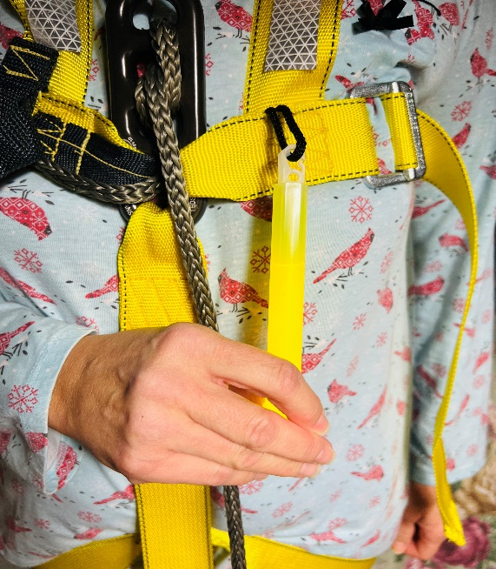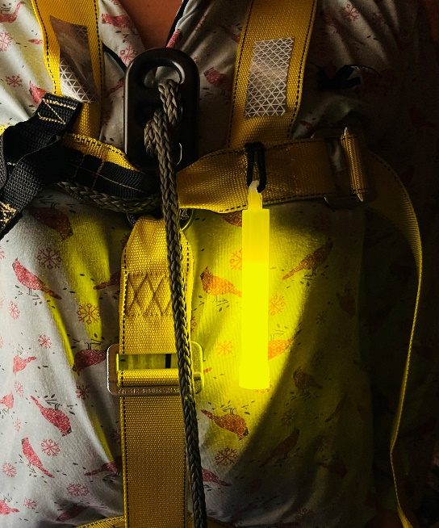
Photo 8B Photo 8C
9 After you have properly put on the FireEscape EDS™ Harness, and before you do anything else, PUT AT LEAST ONE HAND ON THE EASY-GRASP BRAKE HANDLE AND KEEP IT THERE. Back up to your escape window or opening and make sure the line length is correct to where you can be in your escape window or opening when the line gets tight. PRACTICE KEEPING AT LEAST ONE HAND ON THE EASY-GRASP BRAKE HANDLE.

10 If at anytime after putting on the FireEscape EDS™ Harness, you need more line, push down on the line between the Brake and the 1EDS Rack forming a small loop. This will pull more line from the Line Bag. Then allow this loop of line to be pulled up through the 1EDS Rack as you back up, or pull the line up through the 1EDS Rack with your hand. Photo 10

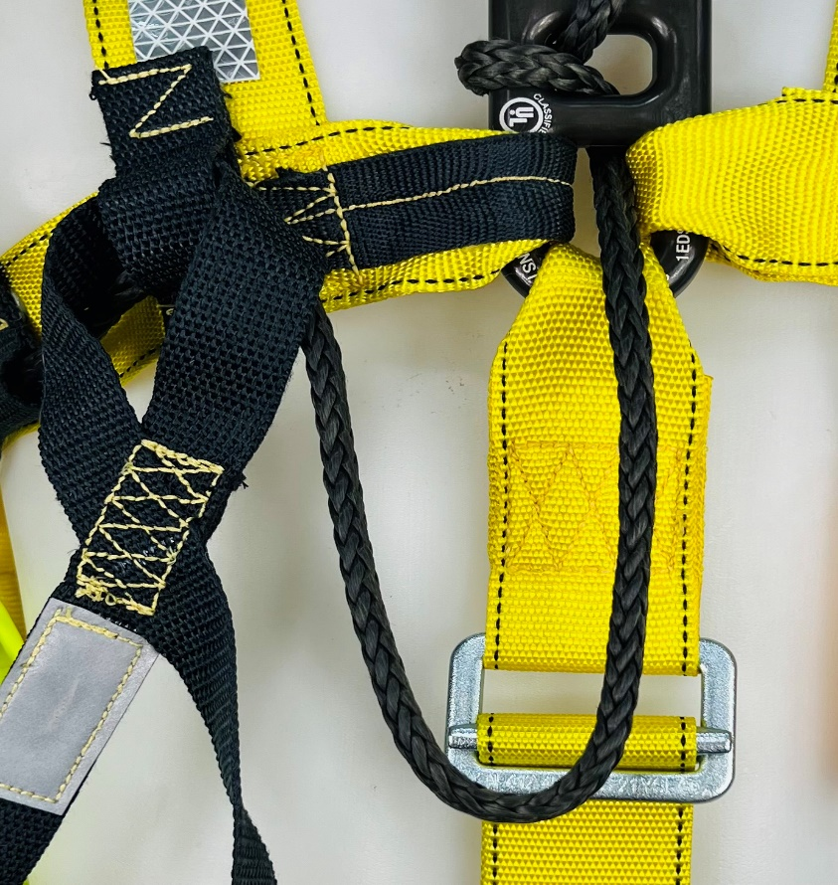
Photo 10, Doing this pulls line from the Line Bag.

PACKING THE FIREESCAPE EDS™ HARNESS

1 To pack the FireEscape EDS™ Harness, make sure the Chest Strap and Leg Strap is extended to where there is only 6” of free end remaining next to the buckles. You want plenty of room to put the harness on in a hurry.

2 Place the FireEscape EDS™ Harness in the storage container with the rear of the Chest Strap and the Shoulder Straps “V” on top. Place the Glow Stick on top of the “V”. Close the storage container and place it under the bed. NOTE – The Line will be exiting the storage container. The storage container lid will still snap close on the line. Photo 2A, 2B

Photo 2A Photo 2B

3 Lay the remaining Anchor Line or FireEscape EDS™ Harness Line under the bed next to the storage container.

4 If you are in an office setting, you may not be able to previously set up the FireEscape EDS™ Harness Anchor Line. In that case, place the Anchor Line, carabineer, and any extended line in the storage container first.

5 Place the FireEscape EDS™ Harness in the storage container next with the
rear of the Chest Strap and the Shoulder Straps “V” on top. Place the Glow Stick on top of the “V”. Close the storage container and place it near your escape window or opening.
WHAT TO EXPECT IN AN ACTUAL EMERGENCY

1 You must try not to panic. Have a sense of urgency, but do not panic. Be deliberate in your movements. Be focused on what you must do to survive. Act decisively, you have very little time! Do not freeze! Move!

2 The best way to avoid panic is to PRACTICE so your movements are second nature in an emergency. Practice often putting on the FireEscape EDS™ Harness. It only takes a couple of minutes. Your life may depend on it.

3 Remember, if you place the FireEscape EDS™ Harness on correctly and have a proper anchor, YOU ARE NOT GOING TO FALL.

4 Keep one hand on the Easy-Grasp Brake Handle at all times. Place both hands on the Easy-Grasp Brake Handle after you have cleared the escape window or opening.

5 Once your full weight is on the line, ease up on the Easy-Grasp Brake
Handle to start your descent. If you hold pressure on the Kevlar Brake, you will not descend. Keep your hand close to your body and slide the Brake Handle up or down your chest with your hand. Sliding the Easy-Grasp Brake Handle up and pushing the Brake Handle towards the line will
help start your descent. The Kevlar Brake is very sensitive and just the
weight of your hand and arm on the Easy-Grasp Brake Handle may prevent you from descending.

6 If the line is slow to slide through the 3EDS Rack, or if you need more line, push down and let up on the line between the 3EDS Rack and Brake to start. This will pull more line from the Line Bag. You must let up on the brake pressure to do this. See Photo 10 on Page 20.

7 After your descent has started, you can push down on the Easy-Grasp
Brake Handle towards your feet to slow or stop your descent. Keep your
Hand next to your chest and slide the Brake Handle up or down.

8 DO NOT HOLD THE LINE WHILE DESCENDING, IT WILL BURN YOUR HAND. With the sternal connecting point, YOU WILL NOT TOPPLE OVER. Place both hands on the Easy-Grasp Brake Handle and keep them there. Keep your hands and clothing away from the 3EDS Rack and Line to prevent jamming while descending.

REMEMBER, THE LONGER YOU ARE SUSPENDED ON THE LINE, THE LONGER
YOU ARE IN DANGER. GET TO THE GROUND AS SAFELY AND AS SOON AS POSSIBLE, AND AWAY FROM DANGER.

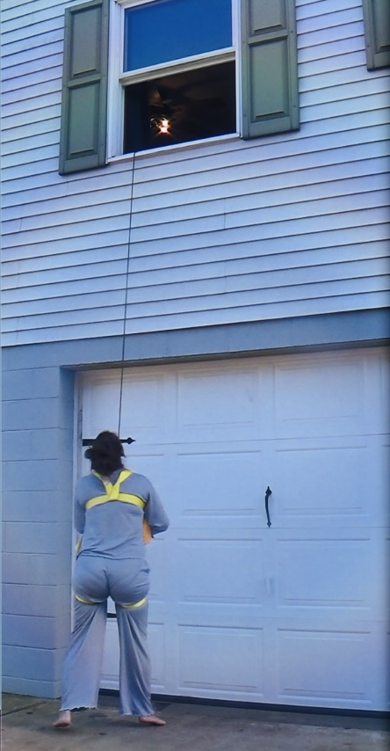
BE PREPARED!

Elevated Safety Systems LLC, 4115 Dragon Hwy, Cameron WV, 26033. Elevatedsafetysystems.com. 304-686-3224. PROUDLY MADE IN THE USA.

